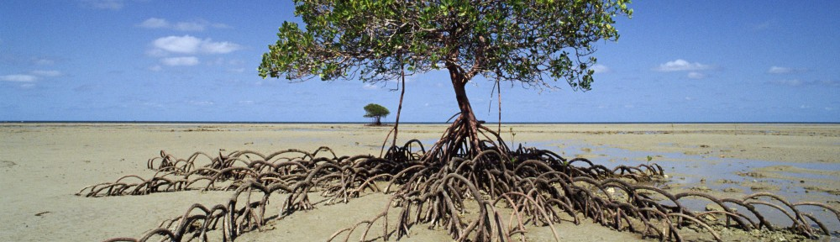
ANZSEE 2015 Conference
Thriving Through Transformation: Local to Global Sustainability
19-23 October 2015
19 Oct Master Classes: Spatial Economics and Environmental Justice
20-21 Oct – Plenary/Concurrent Sessions incl. Indigenous Wellbeing
22 Oct – Field Trips: Oxley Wild Rivers WH or Aboriginal Keeping Place, NERAM and Community Garden
22-23 Oct – Transformation Workshop via Videoconference with GU

APPLICATION FORM
Aboriginal, Torres Strait Islander, Māori & Pasifika Participant Sponsorship
(Covering full Conference Registration and Welcome Drinks only)

A number of places have been sponsored to cover the conference costs of interested people of Aboriginal, Torres Strait Islander, Māori & Pasifika descent to support their role as leaders in their communities to help build a sustainable society. The sponsorship covers participant’s attendance at the Welcome Drinks 19 Oct 2015, both main days of the conference 20-21 Oct, and the Transformation workshop on 22-23 Oct.
A copy of the conference program will be available at www.anzsee.org

If you are interested in applying for this sponsorship, please complete the form below and send to boydb@une.edu.au;

Applications close on 4 September 2015, 5pm

PERSONAL DETAILS

Name: _______________________________________________________________________________

Residential Address:____________________________________________________________________

_____________________________________________________________________________________

Position (if applicable): __________________________________________________________________

Institution/Organisation (if applicable): ______________________________________________________

Alternative contact if appropriate (e.g. supervisor):_____________________________________________

PREFERRED CONTACT DETAILS:

Phone: _______________________________________________________________________________

Mobile:_______________________________________________________________________________

Email: ________________________________________________________________________________

Postal Address:________________________________________________________________________

VERIFICATION:
I confirm that I am an of Aboriginal, Torres Strait Islander, Māori or Pasifika descent, and, if successful, agree to attend the ANZSEE Conference in Armidale from 19 to 23 October 2015:_

Signature:_________________________________________Date:________________

Form continues on page 2

HOW TO SUBMIT

Please submit the following:

(a) The completed form to boydb@une.edu.au; and
(b) Any additional information in support of your application.

If you have any queries, please contact Boyd Blackwell at boydb@une.edu.au +61 2 6773 3279; or Kim McClymont Kim.McClymont@environment.nsw.gov.au +61 2 8977 7026.

TERMS
Applications will be assessed by the ANZSEE Conference Committee with appropriate indigenous input and advice. Successful applicants will be informed before the end of September 2015.

Please note:
- This sponsorship includes registration for all main days of the Conference, the Welcome Drinks, Transformation Workshop, and Dinner.
- Successful applicants will need to arrange and pay for their own travel and accommodation (see Note below).
- Additional options associated with the Conference, including the MasterClass and Field Trips are not included in the sponsorship.

However, if you are having difficulties regarding affording to participate, some non-financial assistance options may be available for a successful applicant with regard to travel and accommodation in some circumstances.
Note: Please contact the conference organisers if assistance is required to attend and we will attempt to identify assistance options such as possible share transport or accommodation, or other low cost transport or accommodation opportunities. No guarantees are given that suitable assistance can be identified or be provided.

D. Please provide additional information to support your application. For example, you might want to explain who you are, what you hope to gain from the experience, how your attendance may have a positive impact on your work or community, why you believe your attendance may have other positive impacts, or why it is important for others to hear what you have to say.
__________________________________________________________________________________________________________________________________________________________________________________________________________________________________________________________________________________________________________________________________________________________________________________________________________________________________________________________________________________________________________________________________________________________________________________________________________________________________________________________________________________________________________________________________________________________________________________________________________________________________________________________________________________

E. If available, please detail and provide / attach evidence of external support or recommendations / referee reports to support your application.
__________________________________________________________________________________________________________________________________________________________________________________________________________________________________________________________________________________________________________________________________________________________________________________________________________________________________________________________________________________________________________________________________________________________________________________________________________________________________________________________________________________________________________________________________________________________________________________________________________________________________________________________________________________

